npmlist - testing

mzakariyya@appcelerator.com/searchEngine

searchEngine contains these dependencies.

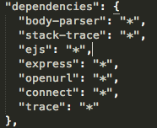

When my npmlist command is run, It outputs the exact same dependencies (shown below)

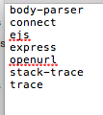

After adding [mzakariyya@appcelerator.com/search](mailto:mzakariyya@appcelerator.com/search) to the applist, and running the command additional modules are added to the output file, duplicate modules are removed.

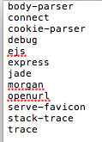

After adding the projects clock, arrowTest and simpleSearch the output is ….

